IST 363 Advanced Front End Web Design

Course Details

Course | IST 363 | Term | Spring 2026
Instructor | Prof. Scharf | Email | jdscharf@syr.edu
Office | Hinds Hall/Adjunct | Office Hours | Wednesdays from 6:35-7:05 PM (In Person in at Hinds Hall Rm 239 (Adjunct Office) after class)  Saturdays (sign up to meet from 11:30am-12pm HERE)
Classroom | Hall of Languages 102 | Meeting Time | Mon/Wed 5:15-5:35pm

Prerequisite
IST 263 – Intro to Front-End Web Development

Audience
Students who have a basic understanding of front-end web development, who are looking to learn some more advanced development techniques.

Catalog Description
Further your knowledge of web development with advanced JavaScript, the latest JavaScript frameworks, CSS libraries, and more. Topics will include faster styling and layout techniques and projects that help you learn the tools professional web developers use.

Learning Outcomes
At the end of the course, students will be able to:
- Explore advanced CSS techniques such as animations and reset stylesheets to standardize and enhance styling consistency.
- Develop expertise with modern CSS frameworks to accelerate the creation of consistent and scalable web designs.
- Gain proficiency in vanilla JavaScript, covering foundational programming concepts and DOM manipulation.
- Transition from vanilla JavaScript to a JavaScript framework, to create dynamic, component-based web applications.

Course Resources

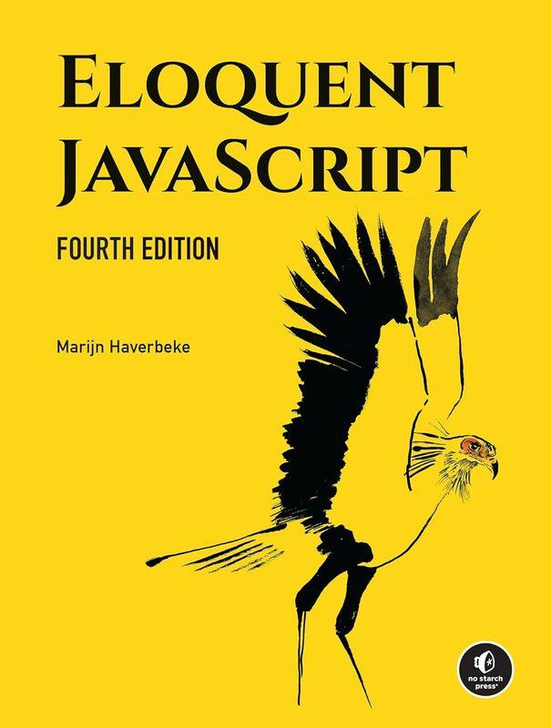
Textbook

Eloquent JavaScript – by Marijn Haverbeke. Available for free - https://eloquentjavascript.net/

Bring Your Own Device
This course uses the BYOD (Bring Your Own Device) model. Please bring your computer to every class. We will be using it to complete activities and work on labs.

Course Software
We will be using the free versions of VS Code, and GitHub Desktop in this class. There is no need to purchase any software to complete your assignments.

Methods of Evaluation

Requirements
Assessment | Quantity | Points Each | Points Total | Percentage
Lecture Work/Participation  (best 12 count) | 14 | 5 | 60 | 12%
Labs  (best 10 count) | 12 | 20 | 200 | 40%
Projects | 3 | 70/70/100 | 240 | 48%

Lecture Work
- Participation will be graded and is based on both classes during the week. You must meet all the following criteria to earn those points:
  - Come to class on time. Attend for the full class period.
  - Answer when called on in class. You don’t need to be correct, just have a thoughtful answer that shows you are engaged.
  - Turn in lecture activity before the end of class.
  - Be engaged in what we are working on in class.
  - Ask questions when you don’t understand the content.

Class Labs
Labs are individual assignments. The lab assignments include posting your files to GitHub and validating them online. Students must resolve the errors when validating before turning in the lab. Labs with validation errors or labs submitted incorrectly will lose points. Late work will not be accepted.

Projects
Projects evaluate your recall and understanding of the course material, as well as your ability to apply it to new situations. There will be three projects in this course. Due dates are posted on the course schedule. Projects must be turned in by the due date. No late work will be accepted.

Collaboration
All the assignments in this class are individual. You are encouraged to collaborate with classmates to understand concepts, however, answers you submit should be 100% your own work.

Use of Artificial Intelligence

Artificial Intelligence (AI): Some Artificial intelligence use
Based on the specific learning outcomes and assignments in this course, artificial intelligence is permitted on the following: Course Projects (Project 1 – All your own work, Projects 2 and 3 – Can use as a tool if you are stuck), Labs (only if you have already attempted it yourself and are stuck). If you do use Generative AI, you must document which model you used, what information you prompted it with, if you changed anything to the response, or kept the returned code as is.
See each assignment, quiz, or exam instructions for more information about what artificial intelligence tools are permitted and to what extent, as well as citation requirements. If no instructions are provided for a specific assignment, then no use of any artificial intelligence tool is permitted. Any AI use beyond that which is detailed in course assignments is explicitly prohibited except when documented permission is granted.

Final Grading Scale

Achievement | Class Points | Registrar Grade | Grade Points
Mastery | 470-500 | A | 4.0
 | 450-469 | A- | 3.667
Satisfactory | 435-449 | B+ | 3.333
 | 415-434 | B | 3.000
 | 400-414 | B- | 2.667
Low Passing | 385-399 | C+ | 2.333
 | 365-384 | C | 2.000
 | 350-364 | C- | 1.667
Unsatisfactory | 300-349 | D | 1.000
 | 0-299 | F | 0.000

Course Specific Policies

Due Dates
All due dates for labs, and projects will be posted in Blackboard. All dates are firm so please plan accordingly. No make-ups are allowed. Any deliverable due outside of class can be handed in anytime on the day it’s due.

Course Honor Code
The course honor code represents our commitment to Academic Integrity in a programming course. I drafted the class honor code to avoid academic negligence - situations where students are unaware that their actions are actually a form of cheating. Our honor code remedies this problem by clearly stating the expectations of Academic Integrity for this course. It states:
- All work is my own. Answers on all student work, assignments (labs, projects, lecture questions, etc…) and assessments (exams, etc…) are my own individual work (except where collaboration is explicitly permitted).
- I will not share answers. I will not make answers (either my own or the professor’s) to work, assignments (labs, problem sets, projects, papers, homework, etc…) available to anyone else in or out of class. This includes posting them on the web or sharing them in test banks.
- I will not misrepresent my ability. I will not engage in any activity which misrepresents or falsifies my knowledge of the subject matter and therefore improves my grade dishonestly. This includes unsanctioned aids and copying homework.
- I will give credit. I will always pay attribution to my sources, and not misrepresent the works of others as my own. If you get code from the web, you must cite it like you would any source in an academic paper.
- I accept the honor code and its consequences. I understand and accept that all work I submit is subject to the honor code, and if I violate this honor code, my instructor is obligated to report me to the University’s office of Academic Integrity.

Sanctions for Violation of Academic Integrity
All suspected academic integrity violations will be reported to the university’s office of academic integrity. Proposed sanction for violations on homework assignments or labs, is a grade of zero. Proposed sanction for violations on an exam or project are an F in the course.

Attendance
Attendance will be taken throughout the semester. If you arrive late or leave early, you will be marked absent. Absences are counted as part of your participation for the week, and you will lose participation points if you are not present.

Syracuse University Policies
Syracuse University has a variety of policies designed to guarantee that students live and study in a community respectful of their needs and those of fellow students. The policies and services are listed on the new Syracuse University Senate approved syllabus appendix titled, ‘Syracuse University Student Policies and Services’. These statements are an official part of this course syllabus.

Course Schedule
The following high-level course calendar lists weekly topics and due dates for labs, projects, and exams. Materials are released in Blackboard each Friday prior to the week it is covered in class.

WEEK | WEEK START | CLASS SUBJECT | LAB | PROJECTS
1 | 1/12 & 1/14 | Syllabus, Setup and HTML/CSS Review | L1
2 | 1/21 | No Class on Monday (MLK) Holiday CSS Animation | L2
3 | 1/26 & 1/28 | Reset Stylesheet & CSS Frameworks: SASS | L3
4 | 2/02 & 2/04 | CSS Frameworks: Tailwind | L4
5 | 2/09 & 2/11 | CSS Frameworks: Bootstrap Week 1 | L5
6 | 2/16 & 2/18 | CSS Frameworks: Bootstrap Week 2 | L6 | P1
7 | 2/23 & 2/25 | Vanilla JavaScript Week 1 | L7
8 | 3/02 & 3/04 | Vanilla JavaScript Week 2 | L8
9 | 3/09 & 3/11 | SPRING BREAK!!!
10 | 3/16 & 3/18 | Vanilla JavaScript Week 3 | L9
11 | 3/23 & 3/25 | JavaScript Framework: React Week 1 | L10
12 | 3/30 & 4/01 | JavaScript Framework: React Week 2 | L11 | P2
13 | 4/06 & 4/08 | JavaScript Framework: React Week 3 | L12
14 | 4/13 & 4/15 | Project Work Days
15 | 4/20 & 4/22 | Project Feedback (4/20) & Project Presentation (4/22)
16 | 4/27 | Project Presentation (Continued) |  | P3

